MAKING CHANGE
KS1 – 2001 Paper
1.
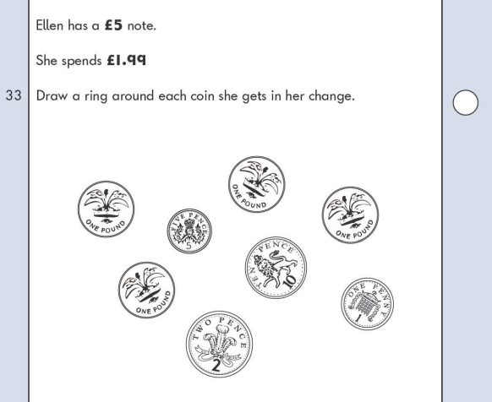
KS1 – 2002 Paper
2.
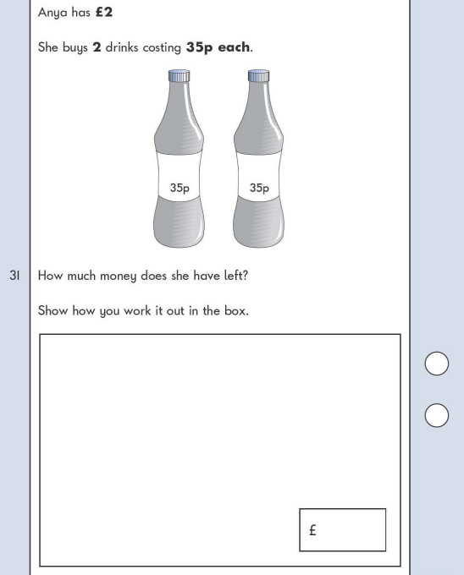
KS1 – 2003 Paper 2
3.

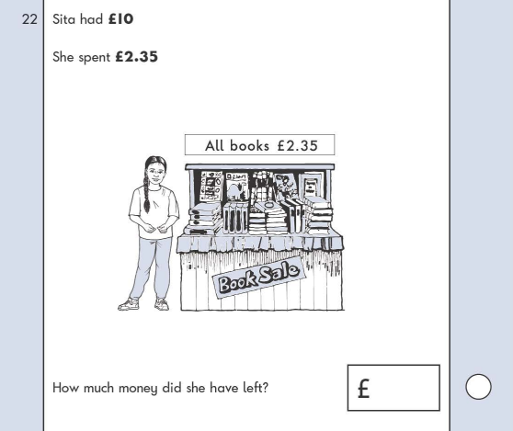
KS1 – 2007 Paper 2
4.

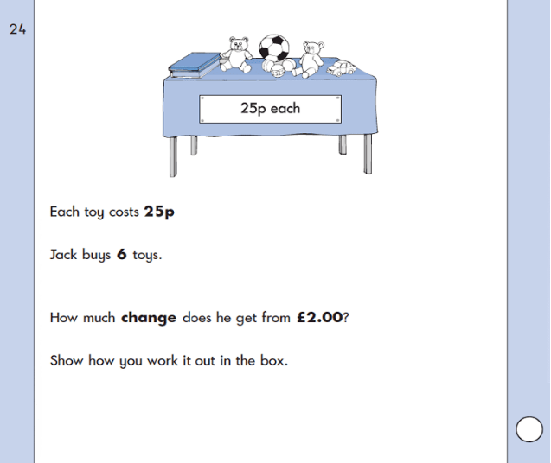
KS1 – 2018 Paper – Reasoning
5.

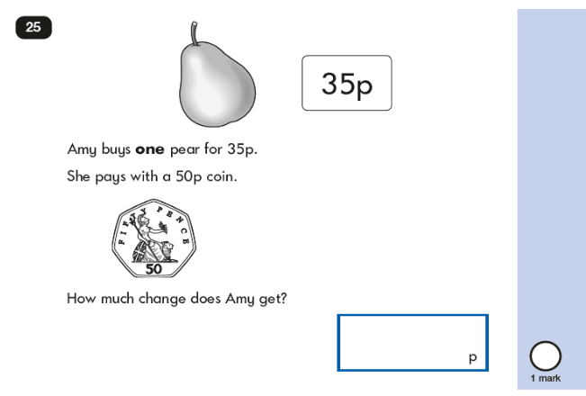
KS1 – 2019 Paper – Reasoning
6.
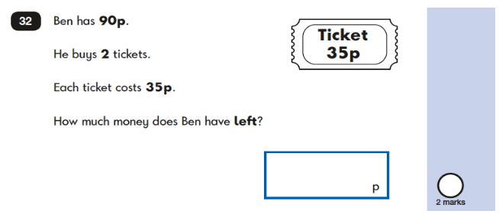

KS1 – 2022 Paper – Reasoning
7.
